Accident Recording Procedure:
Every accident will be recorded on an accident form. This is especially important in respect of the children in a centre environment and the procedure to be adopted is as follows:
- All accidents and incidents involving children are recorded on relevant forms. Forms are to be completed by the practitioner who was present at the time of the accident or incident.
- Any member of staff who sees, or is made aware of any accident to a child, member of staff, trainees, volunteers or visitors must check whether it has been recorded in the accident book immediately or before the end of session.
- Witness statements or signatures should be taken.
- Photographs of any injuries and the environment which it occurred could be taken.
- If an incident or accident results in a child receiving a bump to the head This is then brought to the attention of the manager who is responsible for checking on the child and the details of the event.
- In the event that a child bites another child or adult and draws blood both parties should seek medical attention. An accident and/or incident report form must be completed to reflect this.
- The manager or person in charge must notify Ofsted, DSCP Durham Safeguarding Childrens Partnership and the Health and Safety Executive (HSE) of any serious injury that the child sustains. These injuries include; dislocations, broken bones, cuts or bumps that require medical attention. Further guidance on what is and what isn’t reportable under RIDDOR can be found in the Employee Safety Handbook.
- Where medical treatment is required, the nursery manager will also inform the insurance company in writing. The accident file will be kept for at least 21 years and 3 months.
- Accidents involving a member of staff must be recorded in the staff accident log book immediately or before the end of shift. This log book is kept in the office and is reviewed by the centre manager. In the event that a member of staff or parent sustains an injury, an accident/dangerous occurrences form must be completed and returned to the Health and Safety Executive (HSE) if the incident meets the reporting procedure in the Employee Safety Handbook.
- If a visitor is involved in an accident and is injured, the setting should record all their personal details. The visitor should be contacted the following day to determine if they will be sick from their place of work. A record of their total sickness from their place of work should be recorded and the HSE should be advised if appropriate under RIDDOR.
- Once an accident form has been filled out regarding a child, the parent must be informed and asked to sign the record. We keep this in our accident file and the parent should be asked if they would like a copy. However information will not be shared about any other child who may have been involved in the incident or accident at the time.
- Accident forms must be filed in the accident file once signed and should be retained for at least 21 years and three months
- All incidents and accidents are monitored at the end of each month. Monitoring ensures that any issues or concerns are raised and dealt with on a regular basis and measures taken to prevent further accidents or incidents of that type.
- Where medical attention is required, a senior member of staff will notify the parent(s) as soon as possible whilst caring for the child appropriately.
- Where medical treatment is required for any injury sustained in the nursery by visitors, parents, children, employees or contractors, the nursery manager will also inform the insurance company in writing and record which insurance company was informed. With years to make a claim you may have changed your insurance provider. Should you fail to advise your insurers you will not be covered.
Accident Form
Date
Who was involved in the accident?  (Please circle) | Child  Adult  Member of staff
Name
Date of birth
Date of accident
Time of accident
Place accident occurred
Explain fully the events leading up to the accident and the accident itself
Witnessed by

Position and type of injury - Give details of size of injury and mark on body map
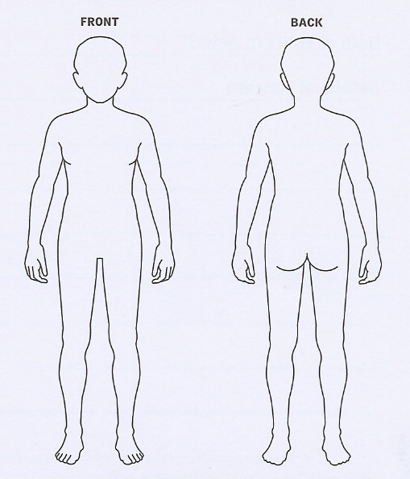

What treatment was provided for the casualty?
Who provided the treatment?

Give details of further medical treatment required? | Contact the parent immediately if this has resulted in a head injury or if further medical treatment is required.
Is there anything we could do to prevent this happening again?
Is a piece of furniture/resource/toy at fault?
If yes, have you removed this? Give details
Witness signature

Staff signature
Manager signature
Parent signature and print name

